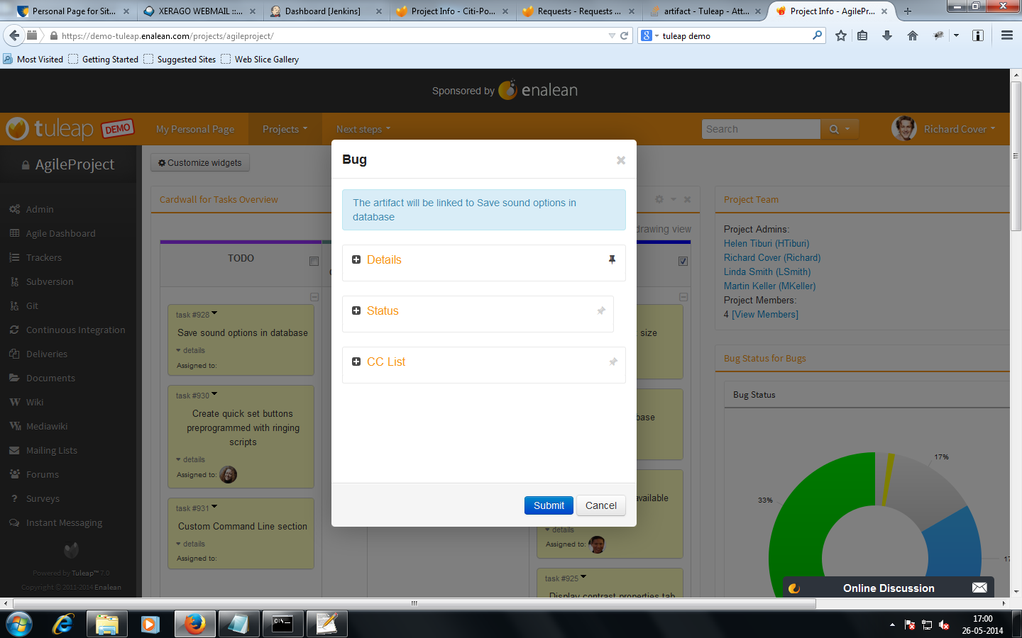
Unable to attach a file, when a bug was raised from the task

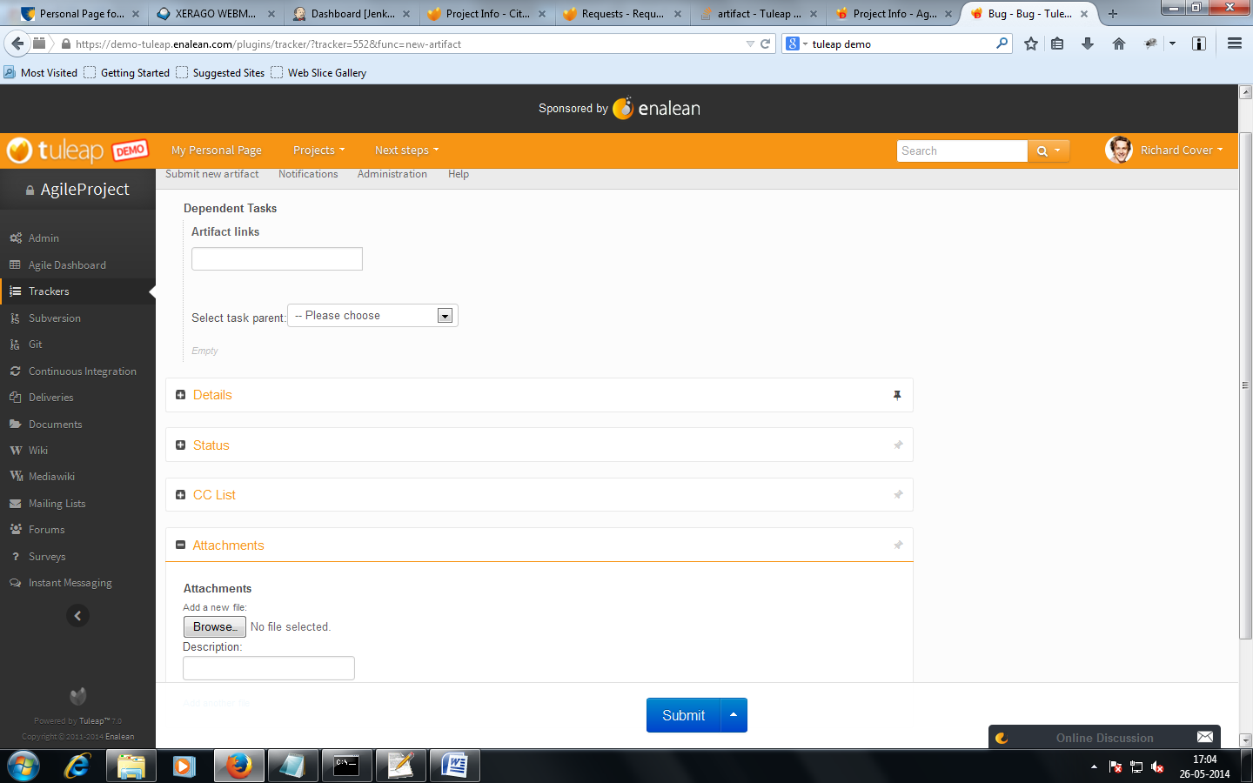
Can attach a bug when it was raised through a bug tracker

